|  |
| --- |
| 2017 |
| Aldridge State High School |
| ANNUAL REPORT |
| 2018 |
| Queensland State School Reporting |
| Every student succeeding  State Schools Strategy  Department of Education |

|  |
| --- |
| Contact information |
|  |

|  |  |
| --- | --- |
| Postal address | PO Box 3061 Pallas Street Maryborough 4650 |
| Phone | (07) 4120 8444 |
| Fax | (07) 4120 8400 |
| Email | principal@aldridgeshs.eq.edu.au |
| Webpages | Additional information about Queensland state schools is located on:   * the [*My School*](http://www.myschool.edu.au/) website * the [Queensland Government data](http://data.qld.gov.au/) website * the Queensland Government [schools directory](https://schoolsdirectory.eq.edu.au/) website. |
| Contact person | Ross Higgins (Principal) |

|  |
| --- |
| From the Principal |
|  |

School overview

Aldridge State High School is a co-educational Year 7 to 12 school located in Boys Avenue Maryborough. Enrolment has remainded around 1000 students since 2009. The school aims to provide a caring but assertive environment for our students, an environment where the bar for academic and behavioural outcomes is set high, but where there is ample support to help our students reach that height. Our curriculum, teaching and timetable are built up from an understanding of how students learn. The school's vision "Engaged students working with expert, accountable staff in a calm, ordered and caring environment" encapsulated our modus operandi. Our school is well-resourced with attractive and well-maintained grounds. Features include a school farm, numerous shaded areas, a swimming pool, extensive computer infrastructure and technical support and a well supported BYOx computer program as well as a large multi-use hall and a specific sports covered area. We believe that academic, vocational and social achievement stem from our motto 'Success through Effort'.

School progress towards its goals in 2018

The primary goals for this school focus on the enhancement of literacy, numeracy and social outcomes. We look to build fine young men and women who have the skills to engage with the modern world. Within this we look to ensure that clear pathways exist between school and the world of work.

The specific sharp, narrow and deep improvement agenda in 2018 focused on Reading, Attendance and Writing.

**Reading Priority**

A specific priority for 2018 focussed on the enhancement of reading skills amongst the Year 7, 8 and 9 cohorts. This priority was linked to the Collaborative Innovation Fund grant the school had received in 2016 which supported the engagement of additional para-professionals (eg: teacher aides) and the upskilling of teachers and teacher aides who would be working with targeted students. Fifty percent (50%) of the total grant was ear marked to support students in our key partner schools. A similar process of engaging addition teacher aide time and upskilling teachers and support staff was applied in these partner Primary schools.

The impact of this initiative was being assessed through specific testing around the decoding and comprehension skills of students as well as using a broader filtered data set based on achievement in English with a specific focus on the students achieving below an age appropriate level (C). Achievement across all subject areas was the final outcome being monitored. The premise around this lay with a view that reading underpins all areas of academic endeavour.

A key finding from the “Illuminate Reading Links” program was that the repetitive nature of the program was more suited to Year 7 and 8 students and teachers working with the Year 9’s reported higher levels of disengagement/reluctance to actively engage from those groups.

The Year 7 cohort of 2016 initially featured 64 students yet to gain mastery of the skill of decoding. By the end of the Year 9 (2018) this number had dropped to 10 students. Across this same period of time an additional 42 students had demonstrated the ability to comprehend text meaningfully.

**Attendance Priority**

Attendance, which has been a key focus of the school’s EIA for several years, remains concerning. A number of new initiatives were put in place in 2018 with no net gain to attendance figures.

Whole of school attendance has vacillated between 89.5% and 90.9% over the last 6 years with a similar pattern – Year 11 and 12 sitting at or above 90% and Year 7 to 10 below 90% but the Year 7’s always sit above 90% in Term 1.

**Other Key Targets**

In the school 2018 Annual Improvement Plan there were 10 key targets noted. Each target had a direct link to an aspect of our school Vision Statement – “*Engaged students (3, 5, 7) learning with expert accountable staff (1, 2, 9b, 9c, 9d, 10b, 10c, 10d, 10e) in a calm, ordered caring environment (4, 6, 8, 9a, 10a)”.*

Performance against these key targets is tracked across the year on a termly or annual basis. The table below notes school performance against the 10 Key Targets for 2018.

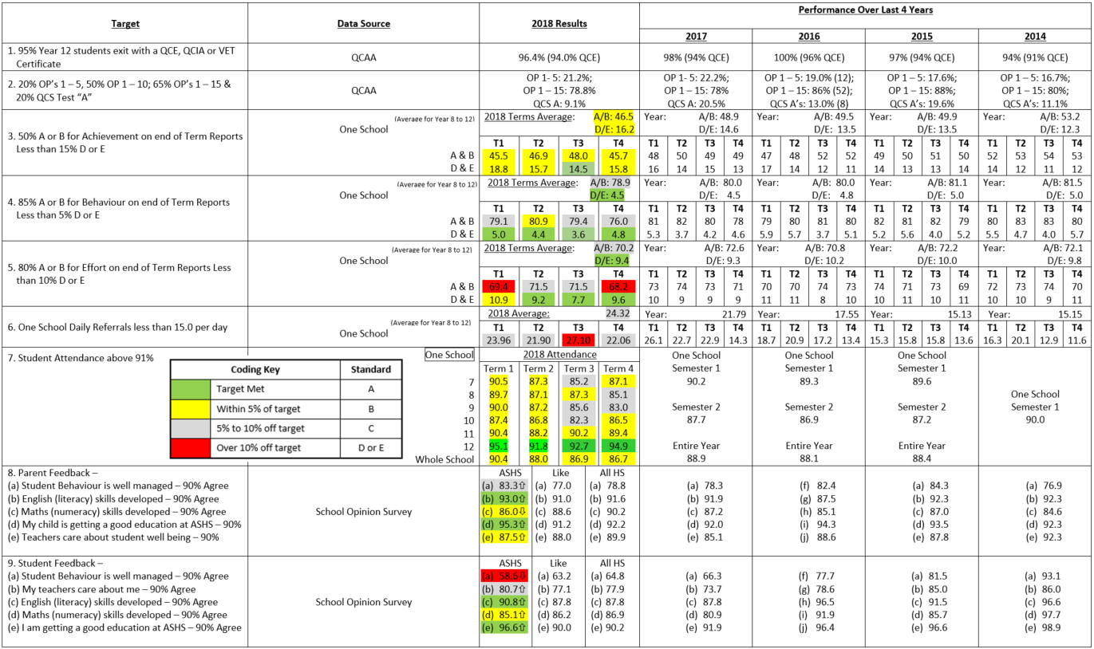

The table above clearly notes the strong linkage between student behavior and staff morale.

**Highlights of 2018**

**Whole School:**

* 107 students (64% of Year 12 cohort) completed either a Certificate II or III level VET Certificate (same percentage as 2017).
* 15 Year 12 students (9% of cohort) completed or were continuing a School Based Traineeships or Apprenticeships by the end of 2018.
* 100% of the 2018 Year 12 cohort with QTAC Applications were offered a tertiary place.
* 79% of OP eligible students received an OP between 1 and 15 with 52% of OP eligible students achieving in the OP 1 – 10 range.
* Over 100 staff & students marched on ANZAC Day.
* Library being open every Sunday from 8.00 am to 12 noon. This has now been occurring for over 9 years & is indicative of the additional support provided to students at Aldridge by committed staff members.
* Aldridge’s Australasian Schools Accreditation Agency rating was retained following an audit in November. Aldridge was the first Regional Queensland school to receive this accreditation status and only the 7th school in the State. Currently around 20 schools in Queensland have this accreditation.
* A past student received one of the USC Chancellor’s Medals having achieved a GPA of 6.95 across his three years of study in the Business faculty.

**Senior Schooling**

* 79% OP eligible students received an OP between 1 and 15.
* 22% OP 1-5 (up from 2017)
* 30% OP 6-10 (up from 2017)
* 17% OP 11-15
* OP 1 – 15 percentage down on 2017 (85% to 79% but still above State Average) however OP 1- 10 percentage was up with 34 students (52% of OP eligible cohort) achieving in this range.
* 28.2% of cohort now attending University or deferred with the intent to attend.
* 99% of students received either QCE or QCIA
* Year 13 program for all Year 12 cohort accessing key community people to help prepare students for university, TAFE, training & work (life after school)
* 14 Senior students accessing University subjects as part of the Head Start program
* Students work experience throughout the year (106 students)
* Senior Leadership Camp & Workshop (18 students)
* 14 students received Early Offer Guarantees (EOGs) to attend USC in 2019.

**Junior School**

* In 2018 there was some instability with the Year Level Co-ordinator positions with the Year 9 position being filled in an acting capacity for the whole year and the Year 7 filled in an acting capacity in Semester 2.
* Enrolments in the Junior School were slightly down on 2017 with the Year 7 cohort only being 170 students. There were still over 550 students across the three years.
* The number of students willing to put their hand up for both “Leaders” and “Role Models” positions is also showing a positive trend. By the end of the year we had a combined total (Leaders and Role Models) of 53 in year 7, 39 in year 8 and 48 in year 9.
* Attendance has been a major focus in 2018 with a rewards system in place for the whole year. The trend of Year 7’s attending above 90% in Term 1 and then this figure dropping slightly each term across the following 15 terms through until the end of Year 10 continues.
* Engagement as measured by students Behaviour and Effort comments on their report cards trended positively with just short of 40% of students across Years 7 to 9 receiving Meritorious Certificates (A’s & B’s for effort & behaviour for all subjects) each term.

**Learning Enhancement Centre**

A total of 119 students with a verified disability enrolled within the Learning Enhancement Centre of Aldridge State High School in 2018.

**The Disability break down of students within the LEC in 2018 was as noted below:**

Autistic Spectrum Disorder 51

Hearing Impairment 6

Intellectual Disability 28

Physical Impairment 3

Speech Language Impairment 29

Visual Impairment 2

**The quartile breakdown of these students is:**

Quartile 1: 19 Quartile 3: 60

Quartile 2: 22 Quartile 4: 17

We had fourteen Year 12 students’ graduate at the end of 2018. All receiving a senior certificate: four (4) receiving a QCIA and nine (8) receiving a QCE. All students that were completing a traineeship through EPIC Employment completed all requirements of the theory side receiving their Cert II in Retail. One student then gained employment with their host employer, Coles.

Aldridge LEC offered an extensive modified curriculum to the students, including; Modified Mathematics, English, Science, Humanities and Modified Art, Home Economics, Physical Education and Agriculture. This reflected in our large number of primary school students who participated in the SWD Transition Program in Term 4. We had twenty students from six different feeder school participate.

**Other Extra Curricular Activities:**

* Grading glasses for the Redcliffe Lions Club
* Roadcraft Excursion to Gympie Road Safety Centre.
* Crocheting poppies for ANZAC Day
* Two Camping experiences (Currimundi & Inskip Point)
* Entering several LEC teams in the Human Powered Vehicle competition
* Gathering teacher resources for the Cambodian Children’s Fund

**English**

* Year12 English Extension class: All students passed with 50% receiving a VHA.
* Senior English: 20% of students verified at VHA level with a further 40% at the HA level.
* **USC Creative Writing Excellence Program:** 8 Seniors participated in 8 week course (as well as 17 Juniors from ASHS and various primary schools)
* **Write A Book in A Day Competition:** 10 teams across Years 7 to 12.
* **Reading Links program:** This program identifies students not yet at an age appropriate level in the Junior School for reading and targets specialised support to these students:

⮚ At the beginning of Term 1: 2018 - 25% identified to participate in the Reading program.

⮚ By the end of Term 4: 2018 - 13.1% remained on the program (a 11.9% decrease).

**Maths**

* NAPLAN: 90% of students in both year 7 and 9 reached the National Minimum standard
* ICAS competition: 3 distinctions, 24 Credits and 15 Merit awards
* Senior: 26% of Maths A, 28% of Maths B and 50% of Maths C OP eligible students received a Very High Achievement.

**Science**

* Science students from across Aldridge performed beyond expectation in 2018 and there were many instances where students showed their excellence and skills.
* Fifteen from year 9, 8 and 7 participated in the annual Science and Engineering Competition run by the University of the Sunshine Coast. The students acquitted themselves very well and showed great team spirit.
* Nine budding engineers from year 7 and 8 made the trip to the Central Queensland Gladstone campus to compete in The Aurecon Engineering group bridge building competition. They showed great innovation and team skills.
* Four of our Year 12 Physics students were recognised by the Australian Institute of Physics for their sterling efforts in Senior Physics all achieving a rating of VHA4 or higher.

**Social Science (History, Geography, Economics and Tourism)**

**Junior SOSE**

* All year 7 students participate in an excursion to test water quality within the local lake and river systems with data analysis produced for a class presentation
* Year 8 students visited the CBD to analyse industry and people use for their geography report on City Liveability.
* All year 9 students visit the Military Museum as a part of their core students around World War 1.

**Senior History (Ancient & Modern)**

* Year 12: 11 students exited with VHA
* 75% of the Ancient History Year 12 cohort achieved a HA or better and 66% of the Modern History cohort
* Senior Ancient History students were involved in an archaeological dig at the Abbey museum allowing access to the skills of acquiring primary sources. From 2018 onwards this activity will be able to be completed in the school’s very own “dig pit”.

**Geography**

* Successful re-establishment of geography into the school curriculum has provided more diverse pathways to future careers and university options.
* 87% of the students studying Geography achieved in the VHA range.
* Senior geography students completed essential fieldwork at various local sites to establish the health of our waterways and issues linked to erosion through farming and deforestation.
* Students analysed coastal management procedures in a full day investigation at Hervey Bay where they looked at both council and State government actions to prevent erosion.

**Economics**

* The successful re-establishment of economics into school curriculum was further embedded in 2018.
* A goal for 2021 is to have re-established the subject to such a level that stand alone classes are required in Years 10, 11 and 12.
* Students were exposed to key guest speakers from community business leaders and union representatives to emphasise the major aspects and role of economics in society.

**Performing Arts**

* The annual performance event “Aldridge Got Talent” attracted a packed house to the Brolga Theatre.
* Similarly the Film and TV awards night filled the school theatrette.
* Drama Club continued to function on a Friday afternoon.
* Music Extension was introduced into Year 7.
* Several past students who have progressed on to the Conservatorium of Music returned to contribute to the school’s music program.

**Business**

* 33% of all Senior business students achieved a VHA.
* Year 9 market day allowed students to showcase their Business skills and creativity and apply knowledge learnt to a range of successful ventures.
* 5 students participated in the 2017 BEAQ Accounting Competition.
* Court house visits to the Magistrates court with students sitting in on a number of cases.
* Simulated office in F6 allowed students to experience a ‘real life’ office situation to better prepare students for pathways in the office administration area.
* Guest speakers from a variety of businesses to give ‘real life’ applications to theory taught.
* Georgia Masters was the successful recipient of a scholarship from Lowes/Penn College.
* 7 year 12 Accounting students attended the Accounting Student Forum at QUT Gardens Point to experience university for a day.

**Agriculture**

* 100% pass rate for Cert II Rural Operations Students through Australian Agricultural College in Year 12.
* Year 10, 11 and 12 Agricultural students participated in the interschool Hoof and Hook at Childers. Aldridge SHS was awarded 1st Place in Senior Novice Judging class and Senior Experienced Judge class. First and third Place Junior Novice Judging class. Placed 2nd, 3rd and 4th in handler classes. One steer bred by the school placed third in light weight class. A Year 10 student won Stockman’s Encouragement Award.
* Steers shown at Hoof and Hook carcass sold to school staff, parents and local butchery.
* Wide selection of vegetables and produce planted, grown, harvested and packed by the students sold to staff and wider community. Including strawberries, broccoli, cauliflower, corn, tomatoes and lettuce.
* 10 student’s competed in the Interschool Equestrian Competition, with interest continuing to grow.Hosted the regional “Hook & Hoof” competition

**Home Economics**

Experience in the real world of Hospitality through catering for:

* QCAA Verification and Moderation
* Meritorious award ceremony
* ATSI cultural painting experience days
* Aldridge night out
* QCS Breakfast
* Math leaders luncheon

2018 saw the continued operation of the “Ridge Café” which functions on a Tuesday and Thursday morning providing coffee and hot chocolate to staff and students while allowing Hospitality students to hone their barista skills.

This has proven to be an excellent learning exposure for students and another “forum” for staff to engage with students.

**Extra Curricular Activities**

**Sport**

2018 was another strong year for sporting performance from Aldridge SHS students.

Qld School Sport conducts Championships in 21 sports. Aldridge competed in all the school sports on offer. An indication of the school’s performance in sport is the growing number of students selected in representative teams. Ten individuals were selected for Queensland and one in an Australian team. Over 70 students gained selection in Wide Bay Teams in 16 different sports. Year 7 Aldridge students have participated in all 12 Years sports with many students gaining selection in Maryborough Teams and going on to higher representation.

Aldridge Teams performed to a very high level, dominating the Maryborough District competitions and performing strongly in the Regional and Queensland Competitions, winning several State Championships and placing first in Nationals in Volleyball.

Aldridge continues to provide a broad range of sports to all levels for students such as Equestrian Events, Ten Pin Bowling, Futsal and Oztag.

Staff expertise continues to develop with more than ten Aldridge Teachers acting as Wide Bay Officials in 2018. Their knowledge and skill is being utilized within the school to develop our students. The commitment and dedication from the Aldridge Staff is a major driving force behind the school’s success.

2018 was another very successful year in which acknowledgement must go to all involved – parents, teachers, school administration, coaches and students. A great team effort resulting in a competitive, enjoyable sporting culture.

**Public Speaking**

* Aldridge fielded six junior teams in the local debating competition.
* Two of these teams progressed through to the semi-final stage.
* Six students entered the speaking aspect of the local Eisteddfod
* Two students entered the Lions Youth of the Year competition. One progressed to the regional level and the other won the Public Speaking award.
* One student entered the Rostrum public speaking competition.

**Chess**

* Twenty students competed in 5 teams in the Wide Bay Chess Competition.

**Human Powered Vehicles**

* All Fired Up HPV team was second in the open mixed general category and Arrows were third in the junior boys school build category at the Maryborough Technology Challenge.

**Super Scribblers Club**

* This group was established by the school’s English Head of Department to provide an outlet for students with a passion for writing. Most of these students had previously engaged with the “Creative Writing” program that is jointly run by Aldridge & the University of the Sunshine Coast. The club meets once each week.

**Explicit Improvement Agenda (EIA):**

In 2018, Reading was the school’s Key EIA and has been commented upon earlier in this report. Attendance and Writing were the two other EIA priority areas.

Support for the 2018 EIA is directly linked to Investing for Success funding (see next page).

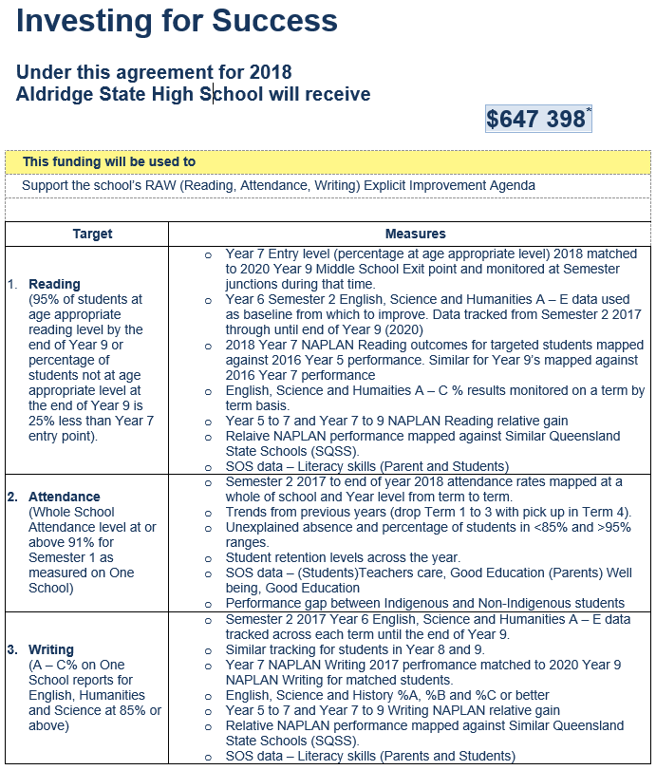

Future outlook

In 2019, the school will continue to focus on Reading, Attendance and Writing.

Overall school performance will continue to be measured through the 10 Key Targets.

A continued focus on providing extension activities to engage our very able academic students will occur. The school’s program to support these students is recognised as the best in the local area but further work in laying the pathway through to the tertiary sector needs to occur.

|  |
| --- |
| Our school at a glance |
|  |

School profile

|  |  |  |  |  |
| --- | --- | --- | --- | --- |
| Coeducational or single sex | Coeducational | | | |
| Independent public school | Yes | | | |
| Year levels offered in 2018 | Year 7 - Year 12 | | | |
| Student enrolments |  | | | |
| Table 1: Student enrolments at this school |  | | | |
| Enrolment category | 2016 | 2017 | 2018 | Notes:  1. Student counts are based on the Census (August) enrolment collection.  2. Indigenous refers to Aboriginal and Torres Strait Islander people of Australia.  3. [pre-Prep](https://earlychildhood.qld.gov.au/early-years/kindergarten-programs/kindergarten-in-indigenous-communities) is a kindergarten program for Aboriginal and Torres Strait Islander children, living in 35 Aboriginal and Torres Strait Islander communities, in the year before school. |
| Total | 1133 | 1100 | 1029 |
| Girls | 565 | 548 | 520 |
| Boys | 568 | 552 | 509 |
| Indigenous | 101 | 92 | 100 |
| Enrolment continuity (Feb. – Nov.) | 90% | 88% | 90% |

Characteristics of the student body

Overview

The make-up of the Aldridge SHS student body has remained relatively stable for last 5 years. In 2018, around 8% of the student body identified as being Indigenous with 11% being identified as part of the Learning Enhancement Centre (Special Education Program). Few of the school’s students have an ethnic background other than Australian.

For many years the school has provided an educational service to a disproportionally large number of students with disabilities (Learning Enhancement Centre – LEC). The percentage these students make-up of the entire school cohort has varied between 10% and 11% for the last decade. With over 25 staff (teachers, teacher-aides and administrative staff) working in the LEC, this is a key area of school operation.

As noted in the table above, the indigenous enrolment percentage has varied between 7.3% and 8.9% over the last 7 years. These students are strongly supported by a Community Education Counsellor who has worked diligently to ensure Indigenous students are provided with opportunities to access both tertiary and trade related pathways.

Student enrolments at the school increased significantly from 2003 to 2007 and again from 2013 to 2016. Enrolment at the beginning of 2018 sat at 1030 and had dropped to 1000 by the August Census date.

A significant number of students come from families at the lower end of the socio-economic spectrum. Over the period 2007 - 2009 there was a decline in the number of students looking to move to tertiary study after the completion of Year 12 however in the last seven years (2011 – 2018) the percentage of students moving from school to university has increased from 17% to 31%.

In 2018, 36.0% of the students who completed Year 12 were OP eligible. This percentage peaked in 2016 when 39% of students were OP eligible.

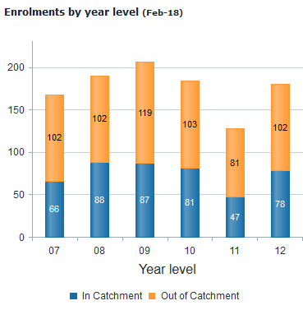The school draws its student population from a large geographic area with more students coming from outside the school’s recognised catchment area as those who come from within the catchment area (as per graph). Our catchment area (as per the majority of Maryborough) is noted as a low socio-economic area and had previously been identified to be included in a national low-SES schools program.

While accepting this as an additional challenge the school does not (and will not) use this as an “excuse” to lower student expectations academically or socially.

ICSEA data noted in the table below shows that in comparison to the National distribution, this school supports close to double the number of students coming from the lowest ICSEA quarter than the National average.

Access to funds at home remains a key consideration when calculating costs associated with all school organised activities.

Average class sizes

Table 2: Average class size information for each phase of schooling

|  |  |  |  |  |
| --- | --- | --- | --- | --- |
| Phase of schooling | 2016 | 2017 | 2018 | Note:  The [class size](https://qed.qld.gov.au/publications/reports/statistics/schooling/schools) targets for composite classes are informed by the relevant year level target. Where composite classes exist across cohorts (e.g. year 3/4) the class size targets would be the lower cohort target. |
| Year 7 – Year 10 | 20 | 20 | 20 |
| Year 11 – Year 12 | 15 | 15 | 14 |

Curriculum delivery

Our approach to curriculum delivery

Aldridge carries a broad, and increasing, range of senior subjects including OP academic subjects, non-OP vocational studies (SAS’s) and an extensive range of Certificate courses available through TAFE, external RTO providers and the Trade Training Centre. The TAFE courses and Tertiary options were run predominantly on Thursdays in 2018. Aldridge is the only Maryborough School that offers QCAA Authority and VET Agriculture related subjects in the junior and senior schools. The school also offers Japanese as a LOTE in junior and senior for those students who particularly wish to study a language other than English. Opportunities to engage with tertiary level study are available and students have accessed USQ, UQ and USC subjects through Headstart and Enrichment programs.

We routinely accept large numbers of students from Primary schools who do not study Japanese - the curriculum offered at Aldridge causes little or no issue in relation to this.

The two semester Extension English program was added to the Senior curriculum several years ago. This program has been included to provide a similar challenge to those students who excel in the English area to the challenge provided by Maths C & Physics to the more able Maths and Science students.

The school has a Learning Enhancement Centre (Special Education Program), which offers a range of inclusion from full main stream classes to individualised specialist assistance classes. In 2018, over 100 students (11% of total school population) were identified as being part of the LEC. Students with disabilities and Learning Difficulties are well catered for at Aldridge State High School.

Creative Industries is a recent addition to our Performing Arts Certificate courses. Outdoor Studies is a recent Certificate II inclusion for students wanting training in outdoor tourism pursuits such as Climbing, snorkelling etc.

An extension program in Physical Education (Volleyball) is offered in Years 7, 8 and 9. The purpose of this program is to support the whole school Volleyball Excellence program which has achieved both State and National honours over the last ten years and in 2018 the Year 11 Boys won Gold in the Honours division and the Year 10 Girls finished 6th.

Our Year 7, 8 and 9 students study in the core areas of Maths, Science, English, SOSE, Physical Education and Japanese (Year 7 & 8). The National Curriculum is followed for English and Maths in Years 7 – 10. Students have extended exposure to the core Science curriculum in Years 7, 8 and 9 to allow for choice amongst the scientific disciplines in Year 10. This allows those students with a scientific bent to study Physics, Chemistry and Biology from the beginning of Year 10 through until the end of Year 12. Additionally this strategy aimed to decrease the number of subject changes occurring during the Year 11 and 12 period with a specific target being 75% of students enrolling in Chemistry, Physics, Biology and Maths B would complete 4 semesters of study in those subjects.

Increasing opportunities for students to choose learning options builds student engagement, interest and effort. Accelerated extension groupings, like-minded groupings and the use of discretionary units, are the routine - not the exception.

It is the quality of the classroom teaching and learning experience that drives us and makes a real difference in the lives of our students. This school is serviced by staff who continually look for ways of achieving even stronger student outcomes and fostering stronger, more positive student - teacher relationships.

Above all - we seek to develop fine young men and women. Research and our experience have led us to change the way we offer and what we offer, to our senior school students. We understand that between 30% and 40% of our students are University bound and have worked hard to develop exciting and worthwhile opportunities and pathways for those students who are not looking at tertiary placement post Year 12.

Some of our recent innovations include:

* Increasing pastoral care aspects for students by supporting the placement of two additional Year Level Co-ordinators.
* Offering an increasing variety of Certificate courses as an integral part of students' timetables
* Industry linked programs with local Engineering and Construction firms
* Links to tertiary sites – USQ, UQ, QUT and USC

To minimise student disengagement during the Year 7 to 10 phase we:

* Extend the Year 6 transition program with specific curriculum focussed offerings
* Use PATR data to group students in Year 7 literacy groups.
* Deliver a targeted reading program to students in Years 7 – 9 below age appropriate reading levels.
* Create an obvious beginning to the Senior Phase of Learning from Day 1 Year 10.

**Closer monitoring and interviewing of students based on Report results**

The school has several processes that ensure a close monitoring of student results exists. In addition to the Parent/Teacher reporting processes that involve four written reports and three planned face to face opportunities, part of the Year Level Co-ordinator responsibilities is to identify those students who have achieved all A’s and B’s at each reporting period as well as identifying those students who have failed to achieve a C in any subject.

In the case of students in Year 11 and 12, students who do not receive at least a C in more than one subject are required to have an interview with their parents and the Head of Department (Senior Schooling) to discuss the appropriateness of subject selection and student engagement with their program of study.

Effort and behaviour of the student body are monitored at a whole of school level through the Meritorious Certificate process and through One School Report data. Year Level Co-ordinators follow up individually with all students who just miss out on receiving a Meritorious Certificate (ie: given just 1 C) to ensure they set the gaining of a certificate as a goal for the following semester.

Meritorious Certificates were introduced into the school in 1996. Monitoring this data provides a snap shot into how effective the school has been in pushing/promoting exemplary behaviour and standards amongst students. The overall percentage of students receiving certificates fluctuates between the high 30’s and low 40’s. To be awarded a Meritorious Certificate all behaviour and effort comments on the most recent report card need to be Very Good (VG) or Excellent (EX).

As well as monitoring Meritorious Certificate data, the school gauges “tone & culture” through One School Report data, Behaviour Referral data, Bullying Survey feedback and School Opinion Survey data.

Behaviour **Key Classroom Climate Behaviour/Effort Data Overview**

2013 2014 2015 2016 2017 2018

Term 1 Term 3 Term 1 Term 3 Term 1 Term 3 Term 1 Term 3 Term 1 Term 3 Term 1 Term 3

A&B 80.6% 80.3% 80.0% 82.8% 81.3% 81.7% 78.8% 82.1% 80.5% 79.5% 79.1% 79.4%

D&E 4.7% 4.8% 5.5% 4.0% 5.2% 4.0% 5.9% 3.7% 5.3% 4.2% 5.0% 3.6%

Effort

Term 1 Term 3 Term 1 Term 3 Term 1 Term 3 Term 1 Term 3 Term 1 Term 3 Term 1 Term 3

A&B 70.6% 70.7% 71.7% 73.6% 73.5% 72.5% 70.1% 74.2% 73.4% 72.5% 69.4% 71.5%

D&E 11.2% 11.3% 9.9% 8.8% 9.6% 9.5% 11.0% 8.4% 9.8% 9.1% 10.9% 7.7%

The behaviour and effort data as taken from end of Term 1 and 3 reports showed a positive trend across the year.

School Disciplinary Absence (SDA) data and behaviour referral data support the belief that 2018 was a year that saw positive growth in the climate of the school.

Class placement in core subjects (English, Maths, Science and SOSE) in Year 7, 8 and 9 is ability based. The placement is reviewed each term based on performance of students’ during that term. HOD’s and teachers discuss results, as well as in class performance, to decide future class placement for each the following term.

Co-curricular activities

The school offers a vast range of student activities including:

* A very strong Volleyball program (National: 16 years Boys - Gold in 2009 and 2015, Silver in 2011; 15 Boys – Gold 2014 and 2017, Silver in 2008; 14 years Boys – Gold 2016; 13 years Boys – Bronze 2013, 13 years Girls - Gold 2014; 14 years Girls – Silver 2015; 15 years Girls – Bronze 2016 and 16 years Girls – Bronze 2017, 16 years Boys – Gold 2018 with at least one team State Champions in every year 2006 - 2018)
* A strong Hockey program across a 20 year time period.
* School Performance events (ie: Aldridge has Talent, Dance Evenings, Instrumental Music Concerts)
* Creative Writing program link with University of Sunshine Coast.
* Science & Engineering Challenge co-ordinated by University of Southern Queensland (four wins in the last eight years)
* Human Powered Vehicle teams (number of students involved represent 8% of the whole school enrolment).
* Strong participation in Public Speaking and Debating and academic competitions.
* Strong Student Welfare component lead by Guidance Officer and including Year Level Co-ordinators, School Based Youth Nurse, Youth Support Co-ordinator and Chaplain.
* Super Scribblers lunchtime and after school writing program
* Strong school presence at the local ANZAC Day march (over 120 students).
* Leadership programs in each Year level that involve more than 150 students across the campus.
* Regular involvement in ICAS (UNSW) competitions.
* Strong links with tertiary sector through Headstart & TPP programs.

How information and communication technologies are used to assist learning

In 2018, the school rolled out to become a BYOx device school from Year 7 to 12.

Aldridge has significant computer and ICT infrastructure and networking. Students access computers via:

* One of the many computer classrooms in the school (six currently).
* Science Foyer computers of which classes and part classes make continual use during normal lesson time.
* Mobile wireless laptop computers.
* Data loggers and specialised graphical calculators in Maths and Science.
* Extensive use of 3D modeller in graphics and full graphics computer room for use during graphics lessons
* Internet research, electronic assignment production are the norm.

Data on One School (Behaviour & Academic) is used to:

* determine learning groups in a number of core areas
* identify areas of strength & weakness within key learning areas (ie: literacy & numeracy)
* compare learning outcomes between groups of similar ability

Social climate

Overview

Above all - we seek to develop fine young men and women. Young people who strive for academic success through individual effort - to gain the highest OP, vocational and special education program results of which they are capable. Each student contributes to the richness of our school. We have a consistent academic emphasis regardless of a student’s ability or the subject studied - our community reputation is very strong and is central to our school’s operation. By positively affecting the way our students live their school life we enrich the way they will live in our community.

Our school vision statement characterises the tone and culture that is aspired to by the school:

*Engaged students learning with expert, accountable staff in a calm, ordered, caring environment.*

The balance of providing a calm, caring, ordered environment so that engaged learning can occur is a fundamental value of the school. It would be fair to refer to the school as a “strict”, but caring school. We are a strong uniform school and this is highly regarded and supported by our community. We support our students’ academic, social and emotional well-being through form meetings, Year level Co-ordinators, specific Heads of Department being assigned to Year 7, 8, 9, 10, 11 and 12 students, purchasing additional Guidance Officer to enhance the Guidance support provided, School Nurse, ATSI support workers, external Alternative Programs Officer, Chaplain, specific targeted student development programs, Youth Support Officer, community organisations and institutions and Meritorious Certificate days.

Graphs & Tables – Tracking Daily Average Behaviour Referrals by Month

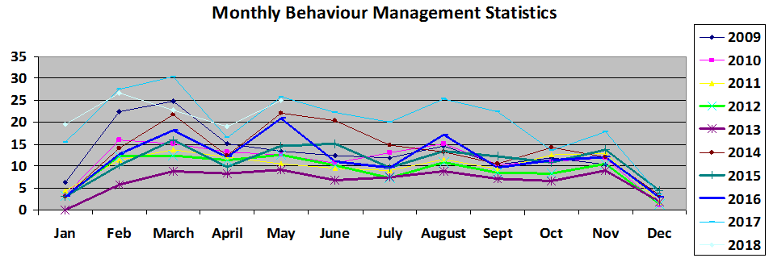

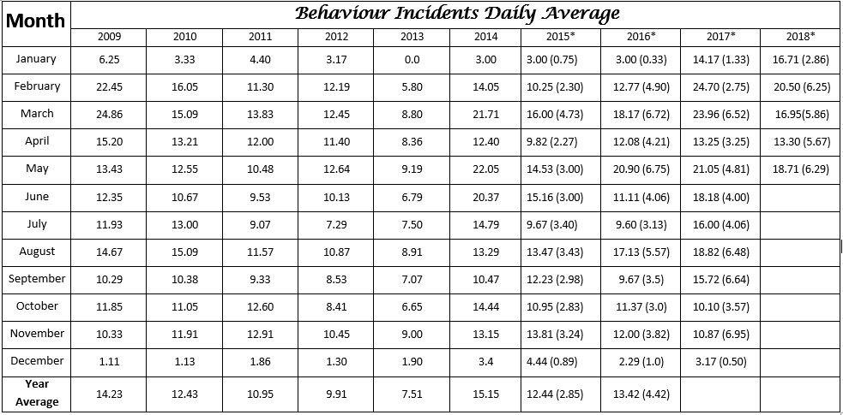

Both One School Behaviour records and the annual School Opinion Survey provide useful data as to how the “social climate” of the school is developing.

The data above clearly notes 2018 as having been one of the most challenging years at Aldridge State High School with regards to managing and responding to behavioural choices made by students.

From a longer term perspective, the graph and table above give support to the belief that the general “tone” of the school steadily improved over the 2010 – 2013 period but lapsed in 2014 especially in the second term (April to June). Once Year 7 data was extracted, 2015 was an improvement on 2014 and sat at a level similar to 2010. Daily referral averages across the year in 2017 were up again in comparison to 2015 and 2016 particularly in the first term of the year.

Key responses on the School Opinion Survey in this dimension are associated with the questions that ask about feeling safe at school, being treated fairly at school, is this a good school, is behaviour well managed and if students are happy to go to this school (highlighted in yellow below). In the case of staff – school morale levels calculated from the School Opinion Survey – give a good indication of tone amongst school employees. This figure rose each year from 2009 to 2013 but dropped in 2014 and 2015. This drop may have some relationship to behavioural data noted earlier. In 2016, staff morale rose by 9% to sit at 87.1% just short of the 90% target but then fell again in 2017.

To proactively address bullying (verbal, physical and cyber) each year the school conducts bullying surveys in Years 7, 8 and 9. From these surveys, students who are identified as bullying others are interviewed to ensure they are aware that this is the perceptions others have of them. Additionally those students who are identified as being bullied are interviewed to see if additional support/skilling can be provided to them.

Cyber bullying has become a significant issue. The school has run sessions both with students and parents to assist in addressing this growing issue over the last two years. Cyber Bullying now has a specific reference in the school’s Responsible Behaviour Management Plan.

Parent, student and staff satisfaction

Tables 3–5 show selected items from the Parent/Caregiver, Student and Staff School Opinion Surveys.

Table 3: Parent opinion survey

| Percentage of parents/caregivers who agree# that: | 2016 | 2017 | 2018 |
| --- | --- | --- | --- |
| * their child is getting a good education at school (S2016) | 94% | 92% | 95% |
| * this is a good school (S2035) | 95% | 91% | 95% |
| * their child likes being at this school* (S2001) | 91% | 91% | 89% |
| * their child feels safe at this school* (S2002) | 88% | 90% | 93% |
| * their child's learning needs are being met at this school* (S2003) | 93% | 89% | 86% |
| * their child is making good progress at this school* (S2004) | 93% | 88% | 93% |
| * teachers at this school expect their child to do his or her best* (S2005) | 97% | 93% | 98% |
| * teachers at this school provide their child with useful feedback about his or her school work* (S2006) | 88% | 85% | 88% |
| * teachers at this school motivate their child to learn* (S2007) | 90% | 85% | 86% |
| * teachers at this school treat students fairly* (S2008) | 84% | 78% | 80% |
| * they can talk to their child's teachers about their concerns* (S2009) | 90% | 85% | 90% |
| * this school works with them to support their child's learning* (S2010) | 86% | 83% | 90% |
| * this school takes parents' opinions seriously* (S2011) | 81% | 78% | 76% |
| * student behaviour is well managed at this school* (S2012) | 82% | 78% | 83% |
| * this school looks for ways to improve* (S2013) | 94% | 89% | 91% |
| * this school is well maintained* (S2014) | 97% | 93% | 91% |
| * Nationally agreed student and parent/caregiver items.  # ‘Agree’ represents the percentage of respondents who Somewhat Agree, Agree or Strongly Agree with the statement.  DW = Data withheld to ensure confidentiality. | | | |

Table 4: Student opinion survey

| Percentage of students who agree# that: | 2016 | 2017 | 2018 |
| --- | --- | --- | --- |
| * they are getting a good education at school (S2048) | 96% | 92% | 97% |
| * they like being at their school* (S2036) | 91% | 77% | 81% |
| * they feel safe at their school* (S2037) | 90% | 88% | 87% |
| * their teachers motivate them to learn* (S2038) | 92% | 78% | 86% |
| * their teachers expect them to do their best* (S2039) | 99% | 94% | 98% |
| * their teachers provide them with useful feedback about their school work* (S2040) | 92% | 84% | 89% |
| * teachers treat students fairly at their school* (S2041) | 78% | 69% | 72% |
| * they can talk to their teachers about their concerns* (S2042) | 83% | 69% | 70% |
| * their school takes students' opinions seriously* (S2043) | 78% | 70% | 72% |
| * student behaviour is well managed at their school* (S2044) | 78% | 66% | 59% |
| * their school looks for ways to improve* (S2045) | 92% | 85% | 91% |
| * their school is well maintained* (S2046) | 90% | 85% | 88% |
| * their school gives them opportunities to do interesting things* (S2047) | 92% | 82% | 88% |
| * Nationally agreed student and parent/caregiver items.  # ‘Agree’ represents the percentage of respondents who Somewhat Agree, Agree or Strongly Agree with the statement.  DW = Data withheld to ensure confidentiality. | | | |

Table 5: Staff opinion survey

| Percentage of school staff who agree# that: | 2016 | 2017 | 2018 |
| --- | --- | --- | --- |
| * they enjoy working at their school (S2069) | 99% | 94% | 93% |
| * they feel that their school is a safe place in which to work (S2070) | 99% | 95% | 98% |
| * they receive useful feedback about their work at their school (S2071) | 92% | 81% | 80% |
| * they feel confident embedding Aboriginal and Torres Strait Islander perspectives across the learning areas (S2114) | 87% | 92% | 89% |
| * students are encouraged to do their best at their school (S2072) | 98% | 90% | 93% |
| * students are treated fairly at their school (S2073) | 93% | 87% | 86% |
| * student behaviour is well managed at their school (S2074) | 92% | 78% | 78% |
| * staff are well supported at their school (S2075) | 90% | 78% | 79% |
| * their school takes staff opinions seriously (S2076) | 89% | 76% | 71% |
| * their school looks for ways to improve (S2077) | 96% | 88% | 90% |
| * their school is well maintained (S2078) | 85% | 87% | 90% |
| * their school gives them opportunities to do interesting things (S2079) | 90% | 83% | 89% |
| * Nationally agreed student and parent/caregiver items.  # ‘Agree’ represents the percentage of respondents who Somewhat Agree, Agree or Strongly Agree with the statement.  DW = Data withheld to ensure confidentiality. | | | |

Parent and community engagement

The school employs many strategies to enable parents to participate in the life of the school. These include:

* P&C, School Council, School Events (eg. Awards Night, Performances, Year 7 Meet & Greet, three Parent Teacher events a year, four reports a year, subject events like “Film & TV Awards Night”, four subject selection nights), EQ surveys, Newsletters, Volunteer work (eg: P&C, Tuckshop), automated text stream to advise parents when students are absent from form meeting at the beginning of the day or about upcoming whole of school/year level event.
* Currently employing a specific officer to increase communications home and to allow greater celebration of student and school achievements.
* Requiring parents to be involved with SET plan interviews and in interviews with Year 11 and 12 when students do not receive at least a C in more than 1 subject.
* The school website has recently been revamped to allow parents to access school & subject information directly. A specific P&C section has been included on the Website. Texts and email interaction between staff and parents about attendance, homework, assignment completion are becoming part of the way business is done
* Aldridge SHS is the home base for the Fraser Coast Volleyball competition as well as hosting a local self-defense group and the Maryborough Roller Derby team.
* For the last 25 years Aldridge SHS has hosted the QCAA (QSA) monitoring and verification processes for the Wide Bay area.

Respectful relationships education programs

Year 7 to 10 Program

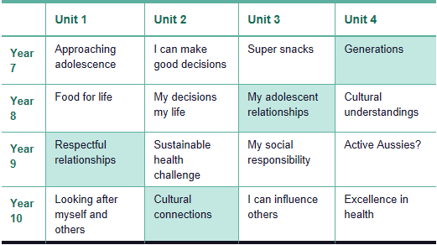

The school utilizes both developed curriculum and specific targeted programs and highlight days to focus on appropriate, respectful and healthy relationships.

The majority of the program is delivered from within the Health & Physical Education curriculum. Additional awareness raising with students and parents around social media, cyber bullying and related IT issues has also occurred.

For students struggling to meet the accepted standard for social interaction on a consistent basis a “No Limits” boys focussed program and “Shine” girl focussed program have been delivered.

Bullying surveys are conducted in Years 7 to 9 to identify students who may benefit from additional interaction with staff where they have been identified as possible bullies or victims of bullying.

Focus days/weeks such as Harmony Day, RU OK Day, Reconcilliation Week and NAIDOC Week are recognised and celebrated to add to the student engagement level focusing on Respectful Relationships. A joint Maryborough State Schools Reconcilliation Week ceremony has been held for the last 10 years. Hosting responsibilities are rotated amongst schools and in 2017 this ceremony was hosted by Aldridge State High School.

School disciplinary absences

Table 6: Count of incidents for students recommended for school disciplinary absences at this school

|  |  |  |  |  |
| --- | --- | --- | --- | --- |
| Type of school disciplinary absence | 2016 | 2017 | 2018 | Note:  School disciplinary absences (SDAs) are absences enforced by a school for student conduct that is prejudicial to the good order and management of the school. |
| Short suspensions – 1 to 10 days | 466 | 548 | 492 |
| Long suspensions – 11 to 20days | 15 | 17 | 14 |
| Exclusions | 10 | 6 | 3 |
| Cancellations of enrolment | 5 | 8 | 7 |

Environmental footprint

Reducing this school’s environmental footprint

The school’s electricity usage has increased each year from 2010 as the classroom climate control program (air conditioning) has progressed. By early 2015 all rooms were air-conditioned except for the newly commissioned rooms associated with Year 7’s moving to High School. This was completed by the end of Semester 1 2015.

Staff are continually encouraged to ensure air conditioners are set at no lower than 240 C and that lights are turned on when entering a classroom and off when leaving.

Water usage is more at the behest of climatic conditions. A significant part of the water usage increase in 2012 – 2013 was due to the school bore being out of action due to pump failure. A feature of the watering plan is a focus on specific key areas (eg: in front of Administration where parents enter the school, the area between C and D blocks where most students gather at Recess). In dry times these areas will be watered but most of the grounds are noted as relying on natural rainfall.

To limit water requirements for gardens a number of tanks have been put in place to collect and store run off from buildings.

Significant water loss issues were identified with the swimming pool during the course of 2016 leading to it being closed and emptied in the middle of the year.

A new pool was constructed during the latter half of 2017 which resulted in a large amount of water use linked to the initial filling of the new pool.

Table 7: Environmental footprint indicators for this school

| Utility category | 2015–2016 | 2016–2017 | 2017–2018 | Note:  Consumption data is compiled from sources including ERM, Ergon reports and utilities data entered into OneSchool* by schools. The data provides an indication of the consumption trend in each of the utility categories which impact on this school’s environmental footprint.  *OneSchool is the department's comprehensive software suite that schools use to run safe, secure, sustainable and consistent reporting and administrative processes. |
| --- | --- | --- | --- | --- |
| Electricity (kWh) | 463,717 | 679,214 | 371,993 |
| Water (kL) | 12,602 | 13,073 | 17,348 |
|  |  |  |  |

School funding

School income broken down by funding source

School income, reported by financial year accounting cycle using standardized national methodologies and broken down by funding source is available via the [*My School*](http://www.myschool.edu.au/) website at.

How to access our income details

1. Click on the *My School* link <http://www.myschool.edu.au/>.
2. Enter the school name or suburb of the school you wish to search.

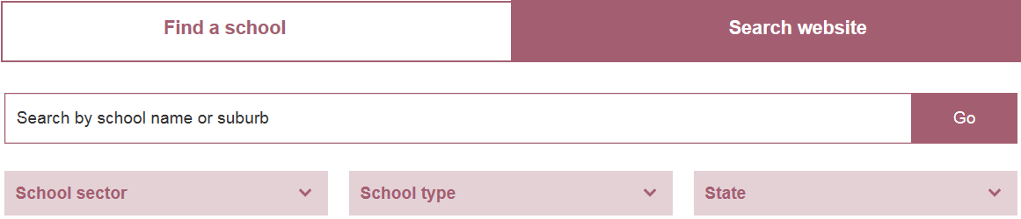

1. Click on ‘View School Profile’ of the appropriate school to access the school’s profile.



1. Click on ‘Finances’ and select the appropriate year to view the school financial information.



Note:

If you are unable to access the internet, please contact the school for a hard copy of the school’s financial information.

|  |
| --- |
| Our staff profile |
|  |

Workforce composition

Staff composition, including Indigenous staff

Table 8: Workforce composition for this school

| Description | Teaching staff* | Non-teaching staff | Indigenous** staff |
| --- | --- | --- | --- |
| Headcounts | 92 | 58 | 7 |
| Full-time equivalents | 87 | 40 | 6 |
| *Teaching staff includes School Leaders.  ** *Indigenous* refers to Aboriginal and Torres Strait Islander people of Australia. | | | |

Qualification of all teachers

Table 9: Teacher qualifications for classroom teachers and school leaders at this school

| Highest level of qualification | Number of qualifications | *Graduate Diploma etc. includes Graduate Diploma, Bachelor Honours Degree, and Graduate Certificate. |
| --- | --- | --- |
| Doctorate | 0 |
| Masters | 6 |
| Graduate Diploma etc.* | 21 |
| Bachelor degree | 65 |
| Diploma | 0 |
| Certificate | 0 |

Professional development

Expenditure on and teacher participation in professional development

The total funds expended on teacher professional development in 2018 were $ 55 253.73

The major professional development initiatives are as follows:

* Preparation for the new system in year 11 and 12 (SATE).
* Pedagogical Coaching.

The proportion of the teaching staff involved in professional development activities during 2018 was 100%.

Staff attendance and retention

Staff attendance

Table 10: Average staff attendance for this school as percentages

| Description | 2016 | 2017 | 2018 |
| --- | --- | --- | --- |
| Staff attendance for permanent and temporary staff and school leaders. | 96% | 96% | 96% |

Proportion of staff retained from the previous school year

From the end of the previous school year, 95% of staff were retained by the school for the entire 2018.

|  |
| --- |
| Performance of our students |
|  |

Key student outcomes

Student attendance

The overall student attendance rate in 2018 for all Queensland state Secondary schools was 89%.

Tables 11–12 show attendance rates at this school as percentages.

Table 11: Overall student attendance at this school

|  |  |  |  |
| --- | --- | --- | --- |
| Description | 2016 | 2017 | 2018 |
| Overall attendance rate* for students at this school | 89% | 90% | 89% |
| Attendance rate for Indigenous** students at this school | 83% | 85% | 84% |
| * Student attendance rate = the total of full-days and part-days that students attended divided by the total of all possible days for students to attend (expressed as a percentage).  ** *Indigenous* refers to Aboriginal and Torres Strait Islander people of Australia. | | | |

Table 12: Average student attendance rates for each year level at this school

| Year level | 2016 | 2017 | 2018 |  | Year level | 2016 | 2017 | 2018 | Notes:  1. Attendance rates effectively count attendance for every student for every day of attendance in Semester 1.  2. Student attendance rate = the total of full-days and part-days that students attended divided by the total of all possible days for students to attend (expressed as a percentage).  3. DW = Data withheld to ensure confidentiality. |
| --- | --- | --- | --- | --- | --- | --- | --- | --- | --- |
| Prep |  |  |  |  | Year 7 | 91% | 92% | 89% |
| Year 1 |  |  |  |  | Year 8 | 91% | 90% | 88% |
| Year 2 |  |  |  |  | Year 9 | 86% | 89% | 88% |
| Year 3 |  |  |  |  | Year 10 | 87% | 87% | 87% |
| Year 4 |  |  |  |  | Year 11 | 90% | 91% | 89% |
| Year 5 |  |  |  |  | Year 12 | 91% | 92% | 93% |
| Year 6 |  |  |  |  |  |  |  |  |

Student attendance distribution

Graph 1: Proportion of students by attendance rate



Description of how this school manages non-attendance

Queensland state schools manage non-attendance in line with the Queensland Department of Education procedures: [*Managing Student Absences and Enforcing Enrolment and Attendance at State Schools*](http://ppr.det.qld.gov.au/education/management/Pages/Managing-Student-Absences-and-Enforcing-Enrolment-and-Attendance-at-State-Schools.aspx); and [*Roll Marking in State Schools*](http://ppr.det.qld.gov.au/education/management/Pages/Roll-Marking-in-State-Schools.aspx)*,* which outline processes for managing and recording student attendance and absenteeism.

**Aldridge SHS Processes affecting all students:**

* Form teachers mark rolls between 8.40 am and 8.55am each morning.
* ID attend was introduced as the student attendance management software during the course of 2009 and remained the key attendance monitoring program until the end of 2016 when Day Map became the key software package. Text messages are automatically sent to parent mobile telephones following the marking of form rolls if students are noted as absent.
* Year Level Co-ordinators follow up those students who have not explained whole day absence within three days of returning to school. Part day unexplained absence is followed up on the day or the next morning.
* The vigilance of Year Level Co-ordinators and the introduction of the ID attend and then Day Map systems led to a significant decrease in unexplained absence but overall attendance rates have not been significantly impacted upon fluctuating within a 1% range (89.5% - 90.5%) for 8 years.
* Where high levels of unexplained absence occur, letters are sent home reminding carers of their obligation to get students to school and what are the possible consequences for them if students fail to attend school regularly.

Students in “Learning or Earning Phase” and post compulsory students:

In addition to the actions noted above:

* Percentage attendance checks occur every five weeks. Students whose attendance drops below the 80% level are interviewed by Year Level Co-ordinators. Where no valid/justified reason exists for absence, warning letters of cancellation are generated. Students whose attendance rates remain below 80% for an extended period of time risk having their enrolments cancelled.
* Where student’s attendance exemplifies that an appropriate level of engagement with the program of instruction is NOT occurring, then efforts are made to engage the student with a program of instruction that has greater chance of success (ie: enrolment in Certificate courses at TAFE, Community Solutions, TESS).

In 2017, the school recognised those students attending in the 95% - 100% range as a strategy to enhance the proportion of students represented in this attendance group. It was encouraging to see that in 2017 there was a 3% increase in the 95% - 100% percentage attendance group.

NAPLAN

Our reading, writing, spelling, grammar and punctuation, and numeracy results for the Years 3, 5, 7 and 9 NAPLAN tests are available via the [*My School*](http://www.myschool.edu.au/) website.

How to access our NAPLAN results

1. Click on the *My School* link <http://www.myschool.edu.au/>.
2. Enter the school name or suburb of the school you wish to search.



1. Click on ‘View School Profile’ of the appropriate school to access the school’s profile.



1. Click on ‘NAPLAN’ to access the school NAPLAN information.



Notes:

1. If you are unable to access the internet, please contact the school for a hard copy of the school’s NAPLAN results.

2. The National Assessment Program – Literacy and Numeracy ([NAPLAN](http://www.nap.edu.au/naplan)) is an annual assessment for students in Years 3, 5, 7 and 9.

Year 12 Outcomes

Tables 13–15 show for this school:

* a summary of Year 12 outcomes
* the number of Year 12 students in each OP band
* the number of Year 12 students awarded a VET qualification.

Details about the types of outcomes for students who finish Year 12 are available in the annual [Year 12 outcomes report](https://www.qcaa.qld.edu.au/about/publications/statistics).

Additional information about the AQF and the IBD program are available at [www.aqf.edu.au](https://www.aqf.edu.au/) and [www.ibo.org](https://www.ibo.org/).

Table 13: Outcomes for our Year 12 cohorts

| Description | 2016 | 2017 | 2018 |
| --- | --- | --- | --- |
| Number of students who received a Senior Statement | 155 | 150 | 167 |
| Number of students awarded a QCIA | 3 | 6 | 4 |
| Number of students awarded a Queensland Certificate of Education (QCE) at the end of Year 12 | 152 | 140 | 157 |
| Percentage of Indigenous students awarded a QCE at the end of Year 12 | 92% | 100% | 89% |
| Number of students who received an OP | 61 | 45 | 66 |
| Percentage of Indigenous students who received an OP | 8% | 0% | 33% |
| Number of students awarded one or more VET qualifications (including SAT) | 106 | 107 | 107 |
| Number of students awarded a VET Certificate II or above | 99 | 97 | 95 |
| Number of students who were completing/continuing a SAT | 8 | 19 | 15 |
| Number of students awarded an IBD | 0 | 0 | 0 |
| Percentage of OP/IBD eligible students with OP 1-15 or an IBD | 85% | 78% | 79% |
| Percentage of Year 12 students who were completing or completed a SAT or were awarded one or more of the following: QCE, IBD, VET qualification | 99% | 97% | 99% |
| Percentage of QTAC applicants who received a tertiary offer. | 98% | 93% | 100% |
| Notes:  • The values above:  − are as at 11 February 2019  − exclude VISA students (students who are not Australian citizens or permanent residents of Australia).  • *Indigenous* refers to Aboriginal and Torres Strait Islander people of Australia. | | | |

Table 14: Overall Position (OP)

| OP band | 2016 | 2017 | 2018 | Note:  The values in table 14:  • are as at 11 February 2019  • exclude VISA students (students who are not Australian citizens or permanent residents of Australia). |
| --- | --- | --- | --- | --- |
| 1-5 | 12 | 10 | 14 |
| 6-10 | 16 | 17 | 20 |
| 11-15 | 24 | 8 | 18 |
| 16-20 | 9 | 8 | 14 |
| 21-25 | 0 | 2 | 0 |

Table 15: Vocational Education and Training (VET)

| VET qualification | 2016 | 2017 | 2018 | Note:  The values in table 15:  • are as at 11 February 2019  • exclude VISA students (students who are not Australian citizens or permanent residents of Australia). |
| --- | --- | --- | --- | --- |
| Certificate I | 47 | 62 | 50 |
| Certificate II | 97 | 93 | 95 |
| Certificate III or above | 4 | 9 | 3 |

Aldridge students accessed VET trainings from a wide cross section of the vocational spectrum including: Automotive, Building, Communication, Horticulture, Information Systems, Manufacturing, Hospitality, Visual Arts, Tourism, Sport and Recreation, Teacher Education and Sales and Marketing.

Apparent retention rate – Year 10 to Year 12

Table 16: Apparent retention rates for Year 10 to Year 12 for this school

|  |  |  |  |
| --- | --- | --- | --- |
| Description | 2016 | 2017 | 2018 |
| Year 12 student enrolment as a percentage of the Year 10 student cohort | 82% | 81% | 74% |
| Year 12 Indigenous student enrolment as a percentage of the Year 10 Indigenous student cohort | 108% | 83% | 50% |
| Notes:  1. The apparent retention rate for Year 10 to Year 12 = the number of full time students in Year 12 expressed as the percentage of those students who were in Year 10 two years previously (this may be greater than 100%).  2. *Indigenous* refers to Aboriginal and Torres Strait Islander people of Australia. | | | |

Student destinations

The Queensland Department of Education conducts [annual surveys](https://qed.qld.gov.au/publications/reports/statistics/schooling/learning-outcomes/next-step) that capture information about the journey of early school leavers and Year 12 leavers from school to further study and employment.

Early school leavers

The destinations of young people who left the school in Years 10, 11 and prior to completing Year 12 are described below.

In total across the 2018 school year 228 students left the school with 117 of these being in Year 10, 11 or 12.

Of those 117 students in the Senior Phase of Learning who left Aldridge, 11 moved to full time employment, 25 to specific Certificate trainings with Registered Training Organisations (RTO’s), 2 went Overseas, 8 moved Inter-state to continuing schooling, 1 moved to Home Schooling, 31 moved to other schools within Queensland, 14 moved to local schools and 26 did not provide the school with information about their intended destinations.

School Student Support Services (Guidance Officer, Youth Support Counsellor, Year Level Co-ordinator) are engaged when the school becomes aware of students who are considering leaving school with no set further learning or earning plan.

Next Step – Post-school destinations

The results of the 2019 Next Step post-school destinations survey, *Next Step – Post-School Destinations* report (information about students who completed Year 12 in 2018), will be uploaded to this school’s website in September 2019.

To maintain privacy and confidentiality of individuals, schools with fewer than five responses will not have a report available.

This school’s report will be available at <http://www.aldridgeshs.eq.edu.au/Supportandresources/Formsanddocuments/Pages/Documents.aspx>